You have built a Centralized Log Management and Security Auditing Lab (SIEM Deployment).
Specifically, your project covers the following critical cybersecurity domains and engineering components:
1. SIEM Deployment & Architecture
- What you did: You deployed and configured a Splunk Enterprise Indexer on a Kali Linux machine to act as a centralized Security Information and Event Management (SIEM) dashboard.
- Skill demonstrated: Infrastructure setup and port binding (9997) to ingest data streams safely.
2. Endpoint Agent Installation (Log Forwarding) [1]
- What you did: You troubleshooted compatibility issues (CPU architecture mismatch, old GLIBC system libraries, package compression blocks) to manually extract and run a legacy Splunk Universal Forwarder on an enterprise target VM (Metasploitable 3).
- Skill demonstrated: System compatibility engineering, legacy software integration, and system automation pathing (/opt/).
3. Linux Kernel Security Auditing [2]
- What you did: Realizing standard OS text files were insufficient, you activated and configured auditd (the native Linux Audit framework) directly inside the Metasploitable kernel to capture high-fidelity system calls (SYSCALL).
- Skill demonstrated: Advanced operating system hardening and forensic logging enablement.
4. Privilege & Access Configuration
- What you did: You resolved file restriction errors by modifying access permissions (chmod), granting your background collector daemon the secure rights to read restricted system files like /var/log/audit/audit.log.
- Skill demonstrated: Identity access management (IAM) and least-privilege troubleshooting.
5. Secure Cross-VM Networking
- What you did: You successfully bridged communications between an attacker platform (Kali) and a vulnerable server (Metasploitable) over an isolated internal virtual NAT Network layer, parsing live logs locally via index=*.
- Skill demonstrated: Virtualized network design and traffic routing. [3]
.

Multi-VM Centralized Log Management & Security Auditing Infrastructure (SIEM Lab)

Project Overview
This project establishes an internal, centralized Security Information and Event Management (SIEM) and log analysis infrastructure across multiple virtual operating systems within an isolated NAT Network. The primary goal is to securely bridge an enterprise auditing pipeline between an attack-and-reconnaissance platform (Kali Linux) and a vulnerable target machine (Metasploitable 3).
By implementing Splunk Enterprise alongside legacy-compatible endpoint agents and low-level kernel auditing systems, this project creates a live, high-fidelity threat-hunting laboratory capable of tracking malicious system calls, privilege escalation operations, and unauthorized access attempts in real time.
Key Technical Achievements & Domains Covered
- SIEM Architecture Blueprinting: Configured a centralized Splunk Enterprise indexer to listen and ingest cross-network telemetry payloads over dedicated ingestion vectors (Port 9997).
- Cross-Platform Compatibility Engineering: Successfully triaged and solved infrastructure deployment friction—including legacy Linux GLIBC runtime dependencies, old package manager compression blocks (XZ), and pathing misconfigurations—to smoothly deploy a stable Splunk Universal Forwarder on an older enterprise base OS.
- Low-Level Operating System Hardening: Activated and mapped the native Linux Audit Framework (auditd) directly into the target kernel to bypass the lack of modern eBPF support on legacy environments. This captures granular user behaviors and binary runtime trees that standard system files omit.
- Identity Access & Permissions Management: Engineered a secure access workflow utilizing least-privilege folder modifications (chmod), allowing non-root software daemons to read locked system-critical files like /var/log/audit/audit.log safely.

.

Centralized Log Management & Security Auditing Lab (SIEM) Commands Used.
1. Kali Linux SIEM Configuration (Indexer)
Check Package Database
dpkg -l | grep -i splunk
- Explanation: Checks if any version of Splunk is already installed on the Debian-based Kali system by searching the local package manager database.
Reinstall/Install Splunk Enterprise
sudo dpkg -i splunk-10.2.3-4d61cf8a5c0c-linux-amd64.deb
- Explanation: Installs or overwrites the 64-bit (amd64) Splunk Enterprise package using the Debian package manager (dpkg).
Initialize Splunk Service
sudo /opt/splunk/bin/splunk start --accept-license --run-as-root
- Explanation: Starts Splunk Enterprise for the first time from its default location (/opt), accepts the user agreement, and forces it to execute under root privileges.
Register System Shortcut
sudo /opt/splunk/bin/splunk enable boot-start -user root
- Explanation: Configures Splunk to automatically generate systemd configuration files, ensuring it launches automatically whenever Kali boots up.
Check Service Status
sudo systemctl status splunk
- Explanation: Interrogates the Linux initialization system (systemd) to verify that the Splunk background service is actively running and healthy.

2. Metasploitable 3 Endpoint Auditing Configuration
Install Auditd Framework
sudo apt-get update && sudo apt-get install auditd audispd-plugins -y
- Explanation: Refreshes Metasploitable's package lists and installs the Linux Audit Daemon (auditd) to track low-level kernel system calls and events.
Verify Auditd Status
sudo service auditd status
- Explanation: Verifies whether the native Linux auditing daemon is currently active and gathering security logs on the system.
Fix Log File Permissions
sudo chmod 755 /var/log/audit
sudo chmod 644 /var/log/audit/audit.log
- Explanation: Loosens default directory and file restrictions so that non-root background users (like your Splunk forwarder account) can legally read the security logs.
Generate Live Event Test
cat /etc/shadow
- Explanation: Attempts to open a highly sensitive, restricted operating system file to deliberately trigger a security alert inside audit.log for testing purposes.

3. Universal Forwarder Agent Deployment (Metasploitable)
Clean Environment
rm -rf ~/splunkforwarder ~/splunkforwarder-*.tgz
- Explanation: Deletes incompatible, legacy, or misplaced Splunk directories from the home folder to prevent directory path confusion.
Download Compatible Agent Archive
wget https://splunk.com
- Explanation: Downloads a legacy 8.x version of Splunk Universal Forwarder from the web, which is natively compatible with Metasploitable 3's older GLIBC libraries.
Extract to Target Path
sudo tar -xvzf splunkforwarder-8.2.12-a0b2fb1e1cf3-Linux-x86_64.tgz -C /opt
- Explanation: Unzips and extracts the .tgz archive directly into the standard system application repository (/opt).
Start Forwarder Agent
sudo /opt/splunkforwarder/bin/splunk start --accept-license --run-as-root
- Explanation: Launches the background forwarding daemon (splunkd) for the first time, prompts for local credentials, and accepts the software license.

4. Log Pipeline & Connection Routing
Link Agent to Kali Indexer
sudo /opt/splunkforwarder/bin/splunk add forward-server 10.0.2.3:9997
- Explanation: Binds the Metasploitable agent to the Kali Linux SIEM server (10.0.2.3) over the default Splunk ingestion port (9997).
Register Active Monitors
sudo /opt/splunkforwarder/bin/splunk add monitor /var/log/audit/audit.log -sourcetype linux_audit
sudo /opt/splunkforwarder/bin/splunk add monitor /var/log/auth.log
sudo /opt/splunkforwarder/bin/splunk add monitor /var/log/syslog
- Explanation: Instructs the forwarder to actively stream the high-fidelity kernel audit logs, authentication logs, and general operating system system logs over to Kali.
Verify Connected Handshakes
sudo /opt/splunkforwarder/bin/splunk list forward-server
- Explanation: Prints an status overview showing whether the forwarder has successfully opened a pipeline to the Kali IP or if it is disconnected.

5. Threat Hunting Verification (Splunk Web UI Queries)
Find All Events
index=*
- Explanation: The broad query used in the Splunk Search app to ensure data has broken past the 0-event mark and is streaming into the database.
Isolate Audit Data
index=* sourcetype=linux_audit
- Explanation: Filters the incoming log flow to display exclusively the high-security kernel metrics captured by auditd.

.

INSTALLATION PROCESS ON
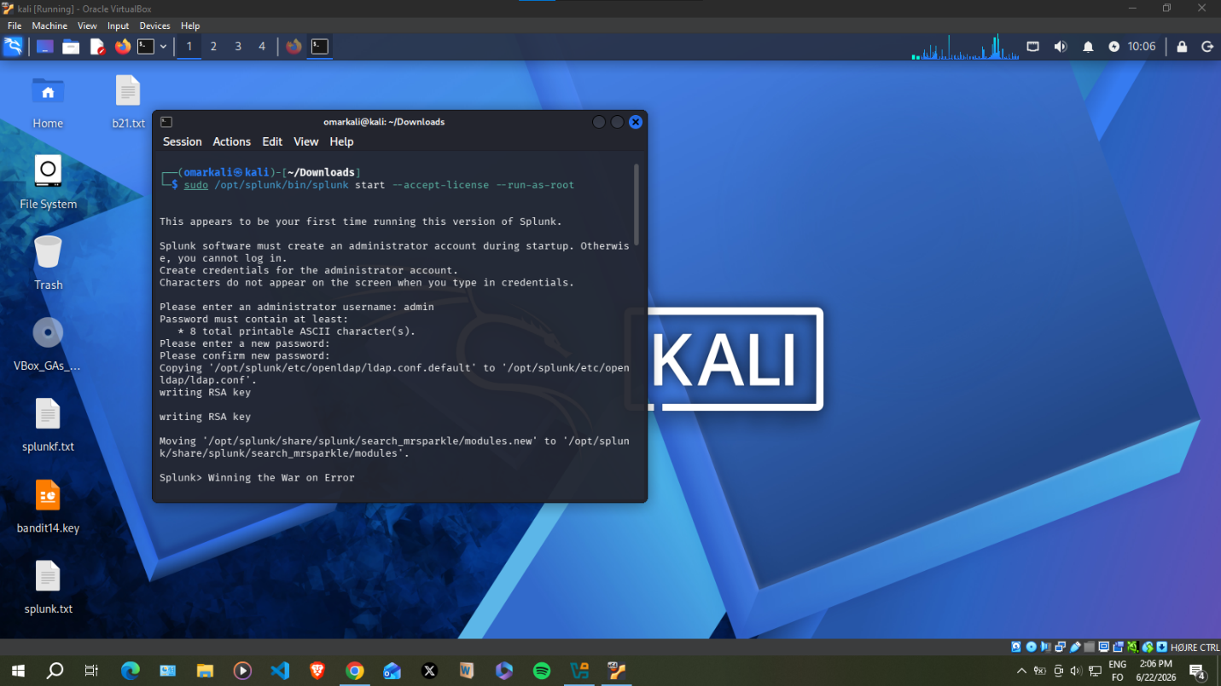

METASPLOITABLE SPLUNK FOWARDER SETUP
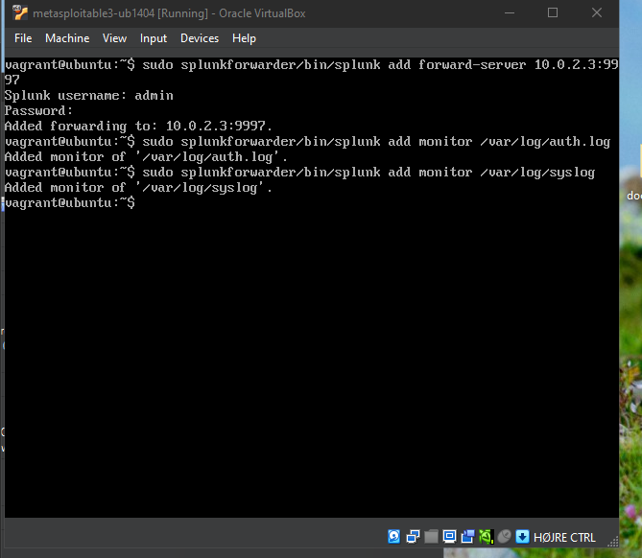

SPLUNK DASHBAORD ON KALI

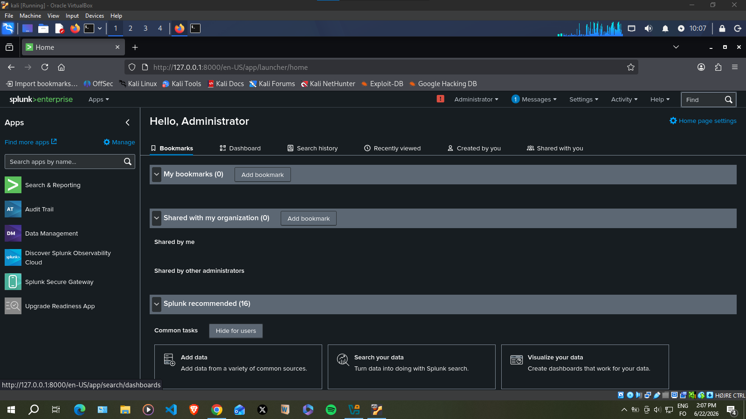

SPLUNK DASHBOARD SHOWING LOGS AND INCIDENT FROM METASPLOITABLE

